***Title of CEP: Modeling a BLDC***

***Domain specification;***

Problem is of pure electrical system in which we can change different parameters to get the different output and effect of certain perimeter on efficiency, power, torque, rpm.

***Problem Explanation;***

Its obvious that all the systems are first theoretically or ideally made and then practical working of the system is obtained however we want to know that in ideal cases the system should have a specific value of rpm say (500) but in practical we get say (300) so how the system lack and all other queries like this are solved after modeling the system.

***Schematic Diagram;***

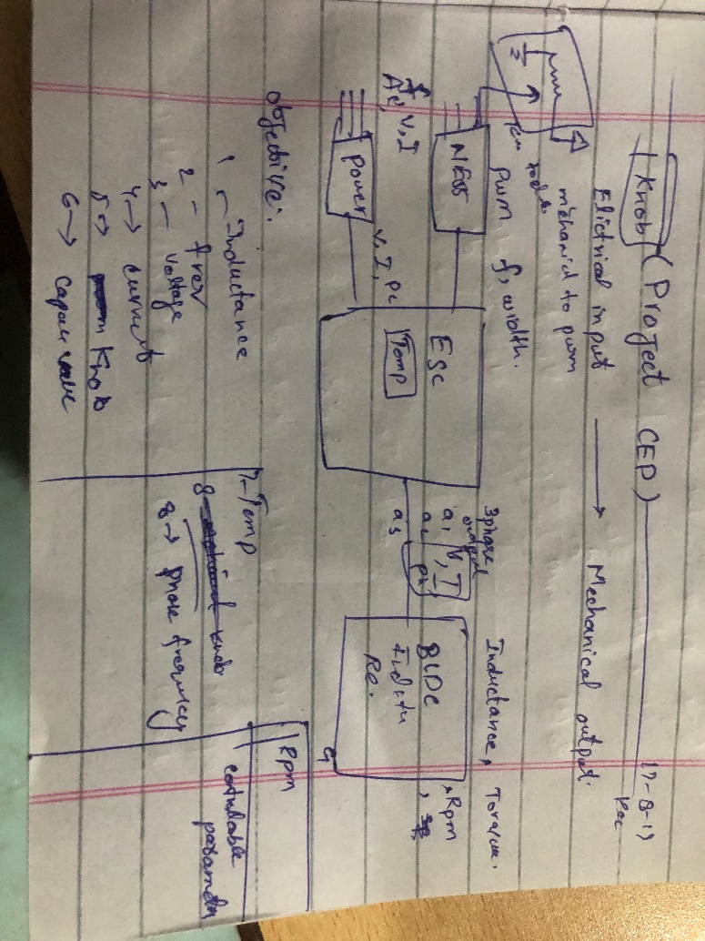

***Objectives;***

To validate the difference between theoretical and practical model of BLDC

***Controllable parameters;***

1. Inductance
2. Frequency
3. Voltage
4. Current
5. Capacitance
6. Temperature
7. Phase
8. Pulse width
9. Load

***Expected Dynamic trends;***

1. Controllable parameters can be plotted against one another

***Name: Haseeb_ul_hassan***

***Roll No: 2022_mc_58***

***Submitted to: Mr. Abdullah Sheraz***